**SMART SWITCH**

A switch that can be remotely monitored and controlled with wifi and gsm devices like mobile phones and smart metres.

**CIRCUIT DESIGN:**

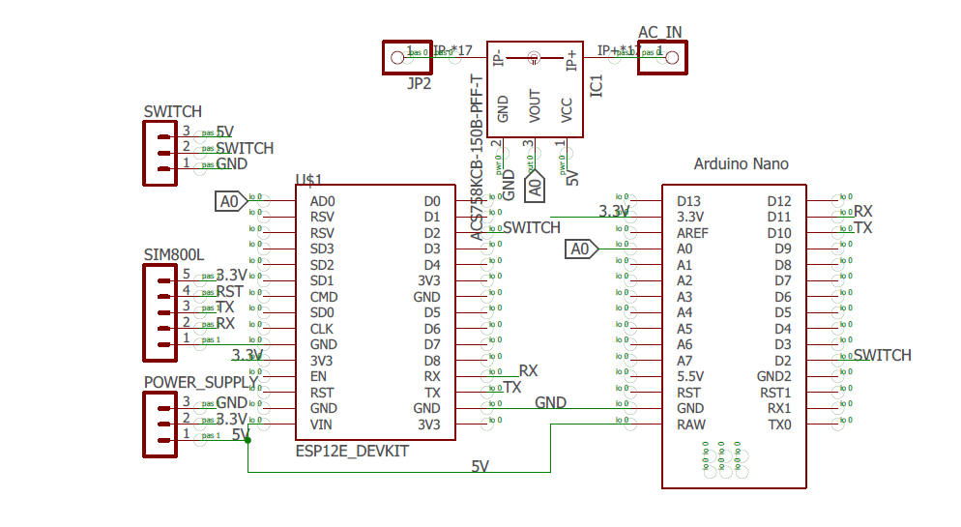

**ESP8266:** WIFI Development board, which is an integrated WIFI chip with integrated TCP/IP protocol stack that can give any microcontroller access to your WIFI network.

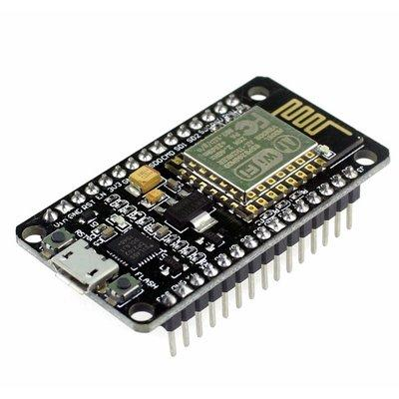

With ESP8266 you can turn off and on the switch with your phone when within the wifi range.

**ARDUINO NANO:** is a small and complete arduino board based on the ATmega328.

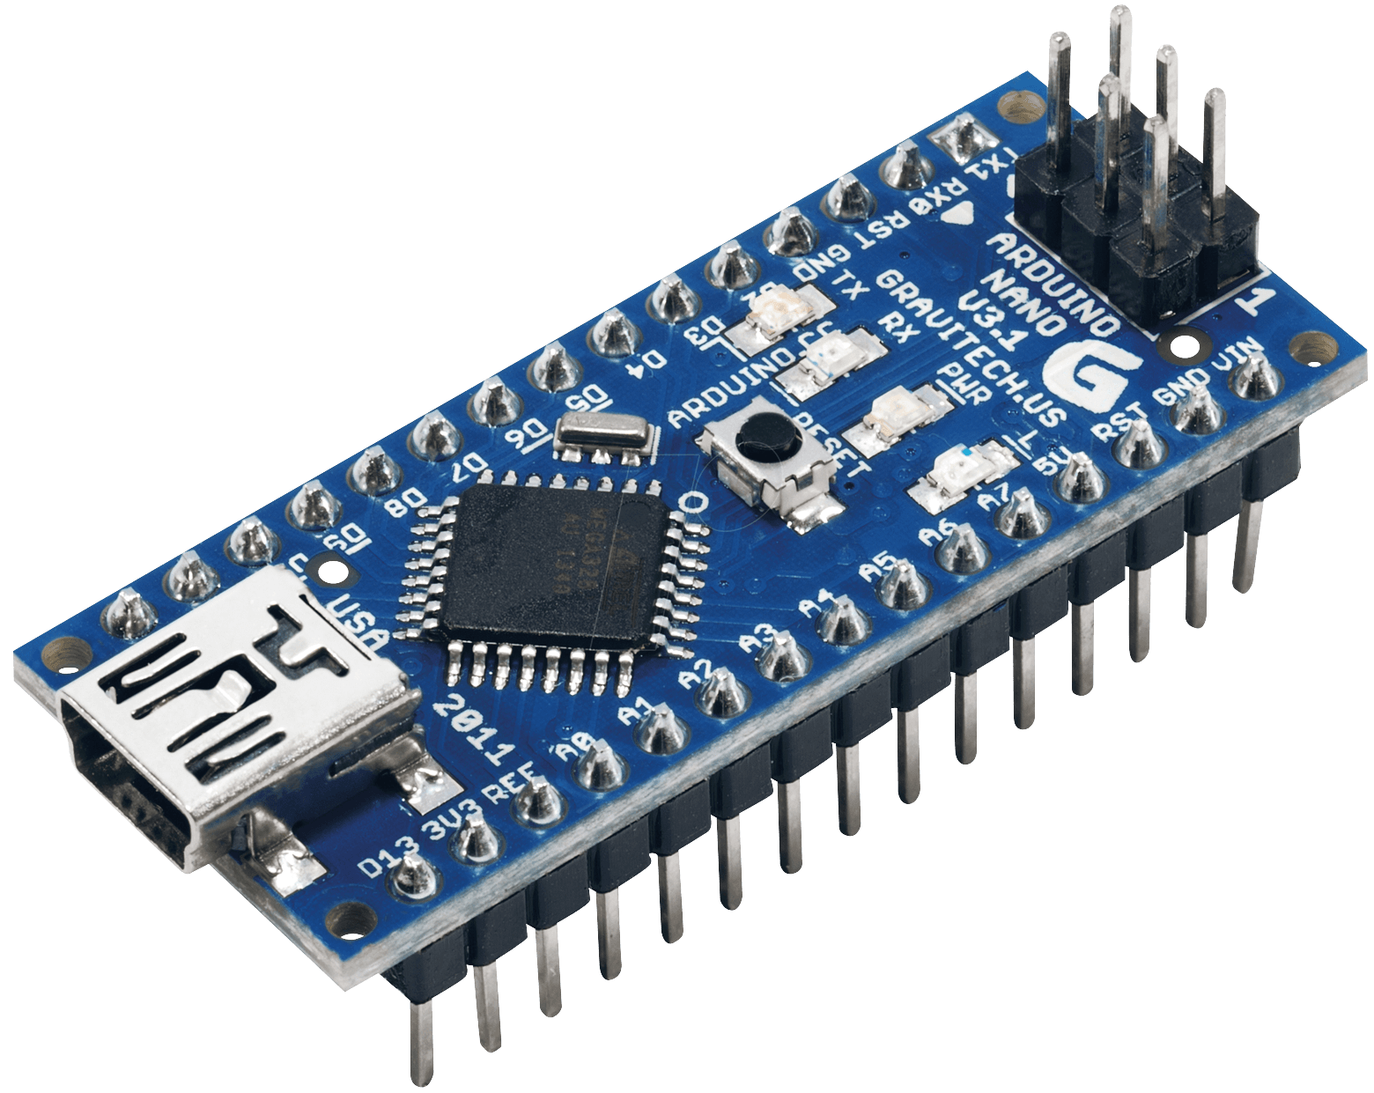

**SIM800L:**  is one of the most commonly used GSM modules among arduino community. It supports quad-band GSM/GPRS network for GPRS and SMS message data remote transmission. 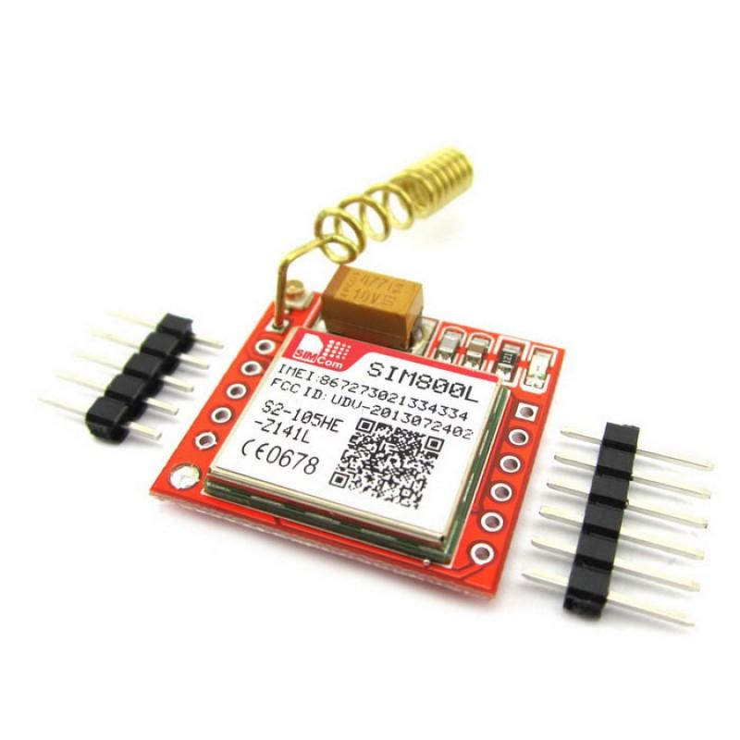 With SIM800L you can turn off and on the switch anywhere with a mobile network.

**SOLID STATE RELAY:** (SSR) is an electronic switch, it allows you to control high-current AC loads with lower voltage DC supply from microcontrollers.

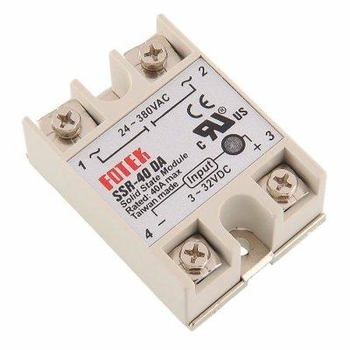

**PCB:** Printed circuit board, I used CadSoft Eagle in the design.

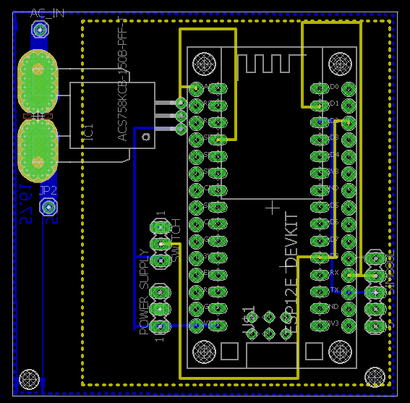

**PACKAGING:**

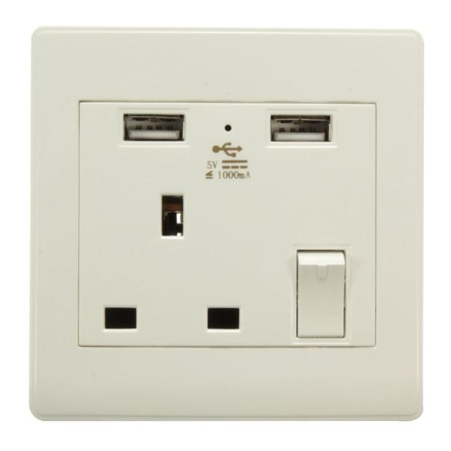

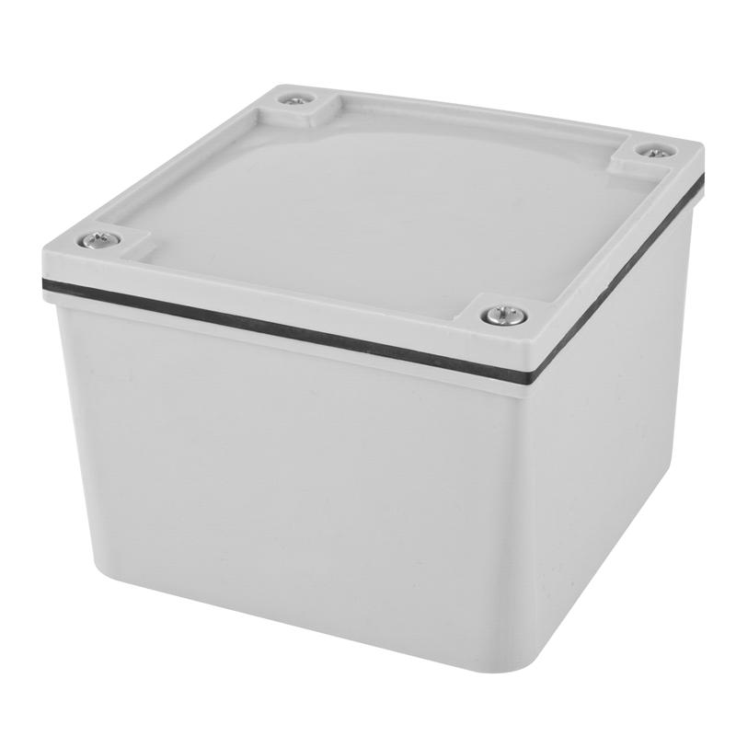

**PRODUCTION COST:**

**2KW**

| **13Amps Smart Switch**  **WIFI only** | **Cost for one**  **(N)** | **Cost for mass production(above10 units)**  **(N)** |
| --- | --- | --- |
| ESP8266 | 5,050 | 3,900 |
| SSR | 5,000 | 2,900 |
| ADAPTABLE BOX | 1,000 | 1,000 |
| AC SOCKET | 2,000 | 2,000 |
| BOARD | 7,200 | 5,000 |
| **TOTAL** | **20,250** | **14,800** |

**2KW**

| **13Amps Smart Switch**  **SMS and CALL Only** | **Cost for one**  **(N)** | **Cost for mass production(above10 units)**  **(N)** |
| --- | --- | --- |
| ARDUINO NANO | 5,000 | 3,600 |
| SIM800L | 6,300 | 5,500 |
| SSR | 5,000 | 2,900 |
| ADAPTABLE BOX | 1,000 | 1,000 |
| AC SOCKET | 2,000 | 2,000 |
| BOARD | 7,200 | 5,000 |
| **TOTAL** | **26,500** | **20,000** |

**2KW**

| **13Amps Smart Switch**  **WIFI, SMS and CALL** | **Cost for one**  **(N)** | **Cost for mass production(above10 units)**  **(N)** |
| --- | --- | --- |
| ESP8266 | 5,050 | 3,900 |
| ARDUINO NANO | 5,000 | 3,600 |
| SIM800L | 6,300 | 5,500 |
| SSR | 5,000 | 2,900 |
| ADAPTABLE BOX | 1,000 | 1,000 |
| AC SOCKET | 2,000 | 2,000 |
| BOARD | 7,200 | 5,000 |
| **TOTAL** | **31,250** | **23,900** |

**2KW**

| **13Amps Smart Switch**  **WIFI, SMS, CALL and Metering.** | **Cost for one**  **(N)** | **Cost for mass production(above10 units)**  **(N)** |
| --- | --- | --- |
| ESP8266 | 5,050 | 3,900 |
| ARDUINO NANO | 5,000 | 3,600 |
| SIM800L | 6,300 | 5,500 |
| SSR | 5,000 | 2,900 |
| ACS712 CURRENT SENSOR (20A) | 3,250 | 2,500 |
| ADAPTABLE BOX | 1,000 | 1,000 |
| AC SOCKET | 2,000 | 2,000 |
| BOARD | 7,200 | 5,000 |
| **TOTAL** | **34,500** | **26,400** |

**40Amps (HIGH POWER, 10KW)**

| **40Amps**  **Smart Switch**  **WIFI, SMS, CALL and Metering.** | **Cost for one**  **(N)** | **Cost for mass production(above10 units)**  **(N)** |
| --- | --- | --- |
| ESP8266 | 5,050 | 3,900 |
| ARDUINO NANO | 5,000 | 3,600 |
| SIM800L | 6,300 | 5,500 |
| SSR | 10,000 | 5,000 |
| ACS758 CURRENT SENSOR (50A) | 10,000 | 5,000 |
| ADAPTABLE BOX | 1,000 | 1,000 |
| AC SOCKET | 2,000 | 2,000 |
| BOARD | 7,200 | 5,000 |
| **TOTAL** | **46,550** | **36,550** |